SUBASHREE.N
LAB EXPERIMENTS
EXP 19: TRIGGER
OUTPUT:
1:
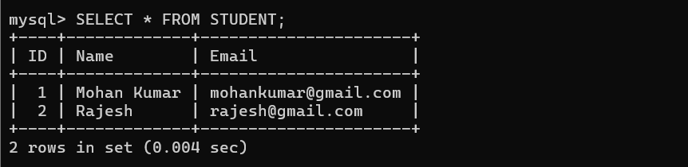
2:
